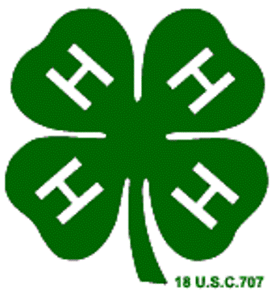
Jackson County 4-H
This Photo by Unknown Author is licensed under CC BY-SA-NC
Project Certification Form
(This Project Certification Form is needed and necessary in order for you to receive
recognition for completing a project. Complete, sign and return it to the appropriate
manager in you club for level of awards.)

NAME OF PROJECT YEAR

NAME: COUNTY:

ADDRESS: ZIP:

PHONE: YEARS IN PROJECT: BIRTHDAY:

NAME OF 4-H CLUB:

ACTIVITIES RECORD
(Record activities and things learned as you completed them during the project)

List specific things learned from this project:

List all activities, demonstrations, talks, judging, activities, exhibits, clinics, workshops, tours, shows, etc.
Participated in and related to this project:

List awards and recognition: medals, ribbons, trips, plaques, scholarships, etc. received in this project:

Page 1 of 2

Leadership, list what you did to assist others in this project. Explain briefly what you did, include numbers
of people taught and involved and list the results for each item.

List community service and citizenship activities related to this project:

PROJECT SUMMARY
Summerize the things you raised, purchased, made or did in this project. Use numbers such as number
of dishes prepared, articles made, people taught, activities participated in and dollars such as profit,
losses, savings or earnings.

Write a brief paragraph explaining what your project has meant to you, including things liked, any unusual
or interesting experiences, goals accomplished and future goals.

This project completed and reviewed:

Date:
Signature of 4-H Member

Date:
Signature of Parent or Guardian

Date:
Signature of 4-H Leader
Page 2 of 2

